Annual  Mid-Year Report | February 13  2008
The mission of the Student Government Association is to act as the official voice of the student body, thereby building trust and support for students, encouraging student involvement, fostering a sense of community on campus, and facilitating effective communication between students and university administration. |  | Johnson & Wales University
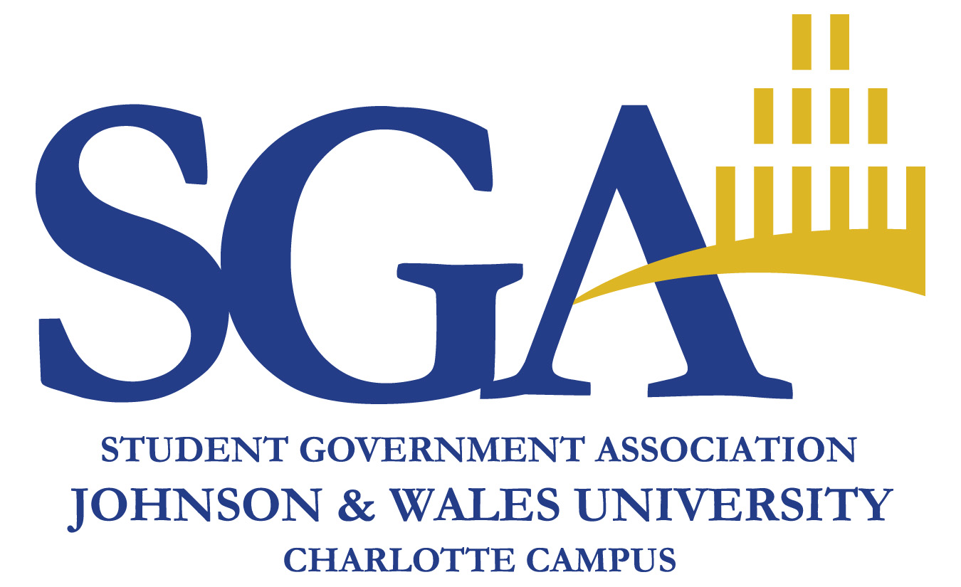

2008
Annual Mid-Year Report

Introduction
The 2007-2008 Student Government Association (SGA) of Johnson & Wales University Charlotte Campus has been working hard to build its organization and reach out to the student body this year. Since September, the organization has grown from 5 to 22 members as we welcomed our new Student Senate.
Who we are: The SGA is comprised of a Cabinet and a 17-member Student Senate (one for every 150 students). The Student Senate has a variety of committees including:
- An Administrative Committee which oversees internal issues
- An Appropriations Committee which oversees the appropriation of funds for clubs & organizations
- A Special Projects Committee which is responsible for SGA publicity
- A Campus and Student Affairs Committee that is responsible for all issues concerning the student body. This committee has four subcommittees:
  - Academics Subcommittee
  - Safety & Security Subcommittee
  - Commuters Subcommittee
  - Dining Services Subcommittee
What we do: As stated in our Mission Statement, the SGA strives to be an effective voice for students. This is accomplished by engaging the student body in various events, surveys, and one-on-one discussions. As part of our newly ratified constitution, the SGA produces an annual general survey to be distributed to the entire student body in order to better understand their needs and wants. Last year, the SGA presented its findings from the annual survey to the administration including some referendum items. These included using design elements throughout the Academic Center and the construction of a Student Center on campus.
For 2008, the SGA included questions regarding student familiarity with and perception of the organization. Over 2/3 of the students rated their perception of SGA as either neutral or N/A. Below is the familiarity results.

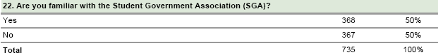

Conclusion: The SGA has a lot of work to do to ensure that it effectively represents the entire student body. We also ask that the administration support the SGA’s efforts and continues to be an advocate for the work that we do.

Overall Satisfaction with University
In 2007, 712 students responded the survey. Of these, 63% of respondents rated their satisfaction with the university as either satisfied or extremely satisfied.
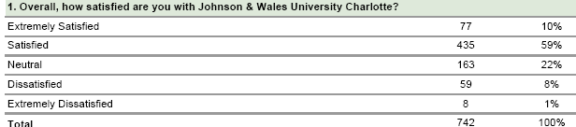
This year, 743 students responded to the survey. Over 500 of them rated their satisfaction with the university as either satisfied or extremely satisfied. This represents 69% of respondents, a full 6points higher than last year.

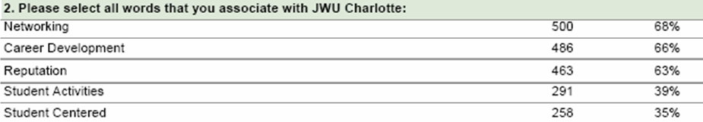
The top 3 terms associated with Johnson & Wales University are “Networking”, “Career Development”, and “Reputation”. These are the same top 3 as in the previous year. Of note, the highest increases in association with JWU were in the terms “Student Activities” by 66% and “Student Centered” by 40%.

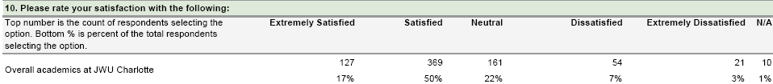
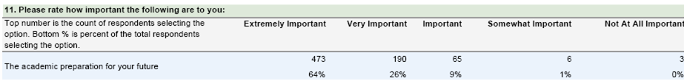
The top reason why students chose JWU was “Career Focus” by a wide margin with almost 75% of respondents choosing it. Additionally, 90% of respondents rated “Academic Preparation for the Future” as being either very or extremely important in academics.
Conclusion: These figures show definite improvement overall and should be noted as an overall impression of the Johnson & Wales University brand.

Safety & Security
In 2007, the SGA found that students wanted to feel safe around campus. Recommendations included more security personnel on campus and in the parking lots, the installation of blue lights, and publicity for the Safety & Security extension.

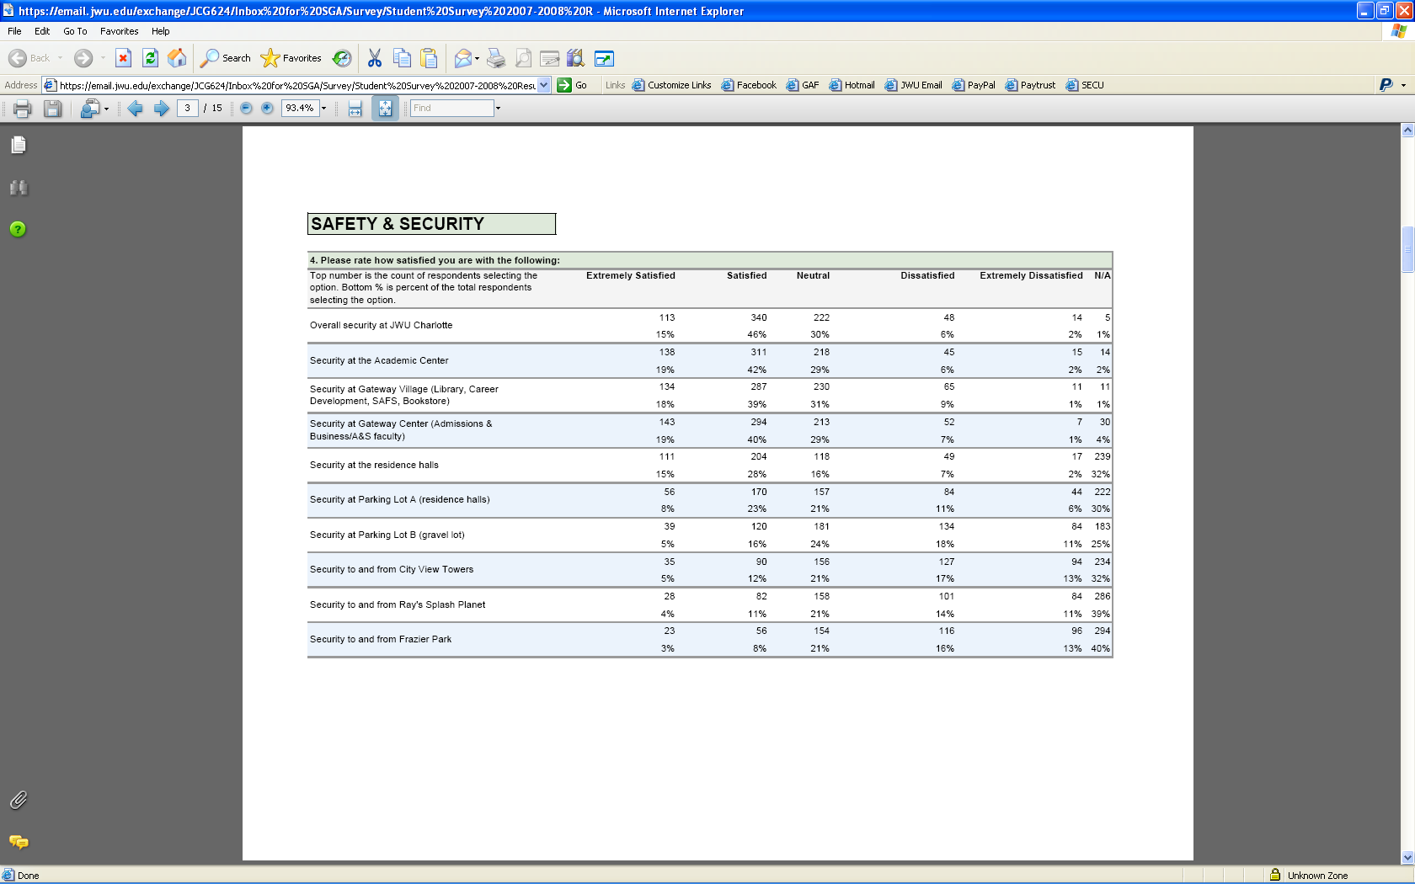
Overall satisfaction with Safety & Security has decreased from last year. Key concerns include:
- Security in Academic Center and parking lot B
- Security to and from off campus locations such as Ray’s Splash Planet, Frazier Park, and City View

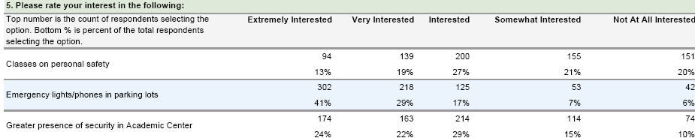
Blue lights or emergency phones continue to rank highly (over 70% of participants), and students also wanted a greater security presence in the Academic Center.

Conclusion: The SGA continues to encourage a greater security presence around campus as well as the installation of blue lights and greater publicity of the security extension. An SGA subcommittee will review these findings with Safety & Security to determine the best way to address these concerns.

Dining Services
In 2007, SGA found that key concerns in dining services included the lack of availability, variety, and affordability of food around campus. Recommendations were to adjust the Dining Center hours, allow the use of JWU ID cards at other locations for food, provide food options in the Academic Center, and provide reasonable pricing for food choices.
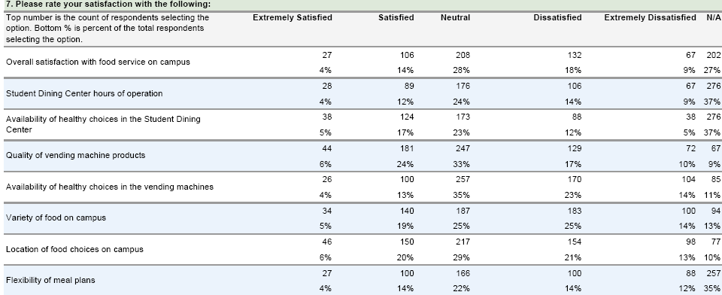
Little change was seen from last year.

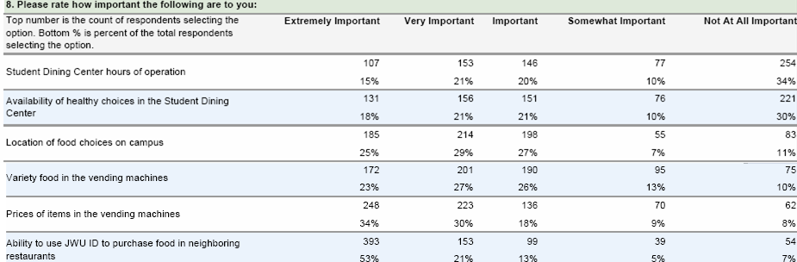
Items stressed this year in the comments include:
- The use of JWU ID cards at neighboring restaurants (almost 75% responded very or extremely important)
- The prices in the vending machines are too high
- The ability to use credit cards in Dining Center
- Flexibility of meal plans
- To go lunches in Academic Center
Conclusion: The SGA will continue to support the recommendations made last year. An SGA subcommittee will meet with the Dining Services Advisory Board in order to review these items.

Student Activities
In 2007, satisfaction with Student Activities was low and the SGA reported the lack of an effective campus communication system. Recommendations included installing more bulletin boards and improving the posting policies.
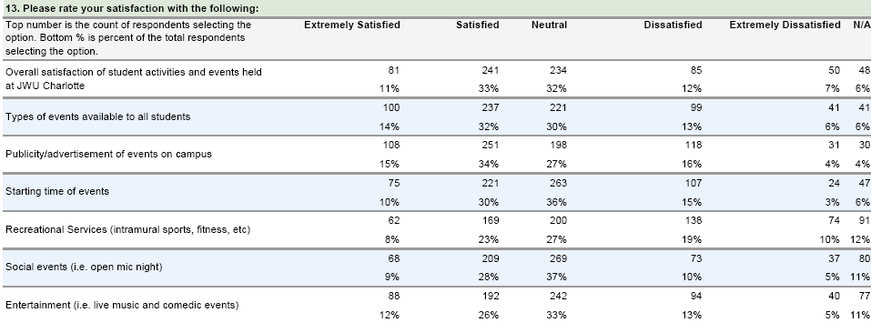
Satisfaction with Student Activities was up 40%. Every area regarding Student Activities showed improvement, and Recreational Services showed an increase in importance. Club involvement was also up 3%. Interestingly, there was a shift from students wanting weekend events to students wanting evening events.

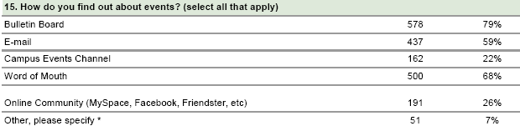
Communication is a factor in Student Activities which the SGA takes great interest in. Respondents most heard about events on campus from bulletin boards (up to almost 80%). Email is down from last year, and word of mouth is up. The SGA feels that there is still room for improvement regarding communication.
Conclusion: While further improvements are being made with regards to bulletin boards, the SGA is moving forward with plans to bring an effective campus communication system to JWU. The system is OrgSync, and it can be found online at www.orgsync.com.

Health & Counseling Services
New in 2008 were also questions regarding Health & Counseling Services.
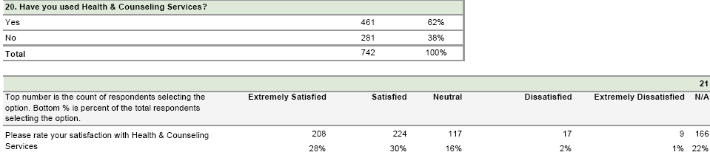
Conclusion: No conclusions have been made by the SGA at this time.

Commuters
Students also expressed concern related to commuter issues throughout the survey, even though there was no specific section for them. Over 45% of Concerns were mainly the availability and affordability of parking spaces.
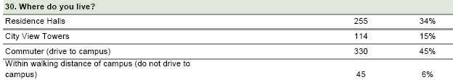
Additionally, 45% of respondents indicated that they drove their vehicles to campus representing an estimated 1125 students overall.
Conclusion: The SGA will work with Operations and Safety & Security to ensure that everything possible is done to attain more parking spaces and control the costs of parking for commuter students. Possibilities currently being explored by the SGA include purchasing spots in neighboring lots priority parking by academic year.

What’s Next?
The SGA is looking for support from the administration both when working with our internal committees and when making decisions impacting the student body. We appreciate all of the help that has been provided and look forward to improving the relationship between the two organizations. The current timetable for follow up is shown below.
- SGA subcommittees will contact respective departments by end of winter term.
- Subcommittees will scheduled meetings to review survey results by the end of March
- The SGA Cabinet will report on the progress and outcomes of these meetings in April

Please contact us with any questions at sga.clt@jwu.edu.

